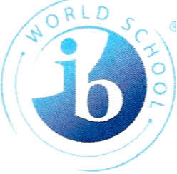

July 25, 2023

Greetings Langford Family,

Welcome to the 2023-2024 school year! I am elated to serve as one of the Assistant Principals at Langford Middle School. I have been an educator for thirteen years. I deeply desire to see our children develop their ability to think so they can be the trailblazer of their life. I also believe that our children are our future. I believe it is my calling to use my talents and skill sets to ensure they have everything they need to take care of the future for themselves and for their communities.

This year our theme is ***"We are IB. Going for the GOLD."*** I am looking forward to partnering with you this year to ensure our students reach the gold in academic achievement and growth, social-emotional learning, and love for their community.

Finally, I am committed to serving the needs of our Langford community. Please feel free to contact me anytime. This year will be a golden year!

Sincerely,

Priscilla Alexander, Ed.S

alexapr@boe.richmond.k12.ga.us